Updating Rock Plugins to .NET 4.7.2

Errors
If you haven’t updated your plugin projects to 4.7.2 yet, you’ll see errors/warnings if you attempt to build
- Error: The type of namespace name ‘Rock’ could not be found
- Warning: The referenced project 'Rock' is targeting a higher framework version (4.7.2) than this project’s current target framework version (4.5.2). This may lead to build failures if types from assemblies outside this project’s target framework are used by any project in the dependency chain.
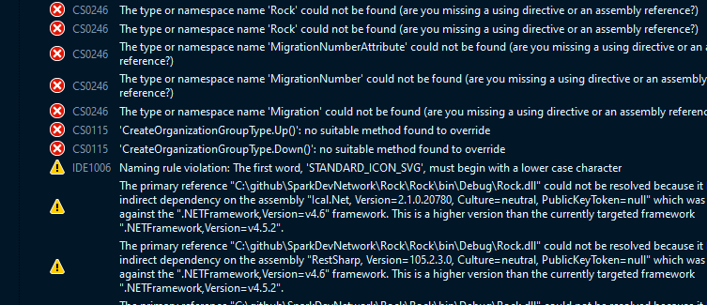

How to update
Change Target framework to .NET Framework 4.7.2
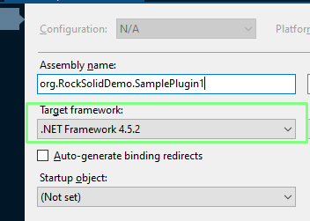
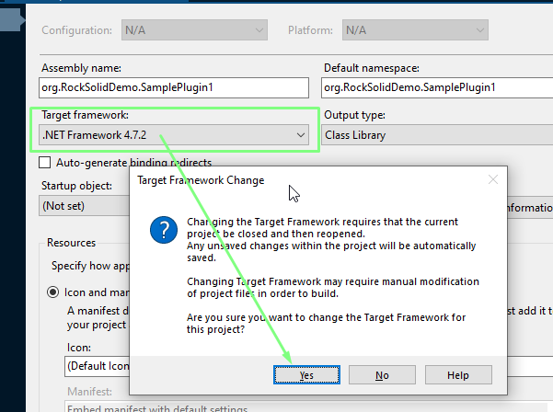

If your project has NuGet packages
Go to Package Manager Console
PM> Update-Package -ProjectName MyProject -reinstall
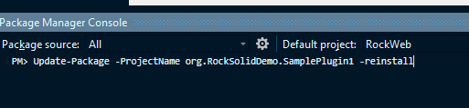
You’ll notice that the packages.config file changes the targetFramework for your packages to net472
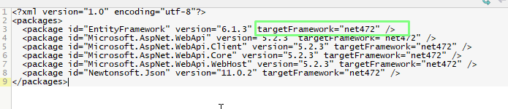

App.Config
You might notice changes to app.config. You’ll probably see that <supportedRuntime version="v4.0" sku=".NETFramework,Version=v4.7.2" /> was added. If so, keep that in there. If there are other changes, review those. It is possible that it made changes that weren’t needed. If you think some of the changes aren’t needed, you might be able to undo those without causing problems.
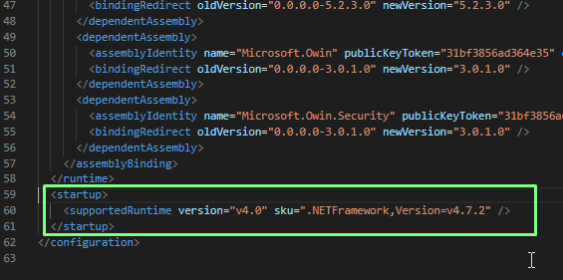

Rebuild
- Rebuild Solution.
- It should succeed, but if not, fix issues

Test
Run RockWeb and see if your plugin works

